Introduction
This document sets out a framework for collaborative multi-agency working using a ‘person-centred solution’ based model. It offers clear guidance to staff working with people who hoard. This guidance has been developed regionally by South West Safeguarding Adult Boards from work undertaken by the Gloucestershire SAB Fire Safety Development sub-group and has drawn on material developed by Nottinghamshire Fire and Rescue Service, Ashfield District Council’s Environmental Health Team and the Nottinghamshire Hoarding Steering Group. It has been updated to include relevant local contact information for Somerset and should be considered in conjunction with the information contained within the Self-Neglect Best Practice Guidance which covers mental capacity and possible legal interventions amongst other things.
There is an expectation that agencies engage fully with the guidance to achieve the best outcome for the individual, while meeting the requirements and duties of their agency or Board.
The Care Act 2014
The Care Act, 2014 builds on recent reviews and reforms, replacing numerous previous laws, to provide a coherent approach to adult social care in England. Local Authorities (and their partners in health, housing, welfare and employment services) must now take steps to prevent, reduce or delay the need for care and support for all local people.
The Care Act introduced three new indicators of abuse and neglect to Adult Safeguarding. The most relevant to this hoarding guidance is self-neglect. The guidance states; this covers a wide range of behaviour neglecting to care for one’s personal hygiene, health or surroundings and includes behaviour such as hoarding. In practice, this means that when an adult at risk has care and support needs, their case may require a safeguarding enquiry.
However, as per the Self-Neglect guidance (to which this hoarding framework is attached) the initial intervention from Adult Social Care would be to offer an individual an assessment of their care and support needs; this may avoid the need to enter formal Safeguarding procedures.
Guidance for practitioners
Listed below are examples of questions you may wish to ask where you are concerned about someone’s safety in their own home, where you suspect a risk of self-neglect and/or hoarding.
Most people with a hoarding problem will be embarrassed about their surroundings so try to ascertain information whilst being as sensitive as possible.
- How do you get in and out of your property?
- Do you feel safe living here?
- Have you ever had an accident, slipped, tripped up or fallen? How did it happen?
- How do you move safely around your home? (Where floor is uneven or covered or there are exposed wires, damp, rot or other hazards)
- Has a fire ever started by accident? Is the property at risk from fire?
- Do you have a working smoke alarm? Do you have any ailments or conditions that would prevent you hearing or responding to it?
- Are there hot water, lighting and heating in the property? Do these services work properly?
- Do you have any problems keeping your home warm?
- When did you last go out in the garden? Do you feel safe to go outside?
- Are you able to use the bathroom and toilet ok? Have a wash, bath, shower etc.?
- Where do you sleep?
- Are there any obvious major repairs that need carrying out at the property?
- Are you happy for us to share your information with other professionals who may be able to help you?

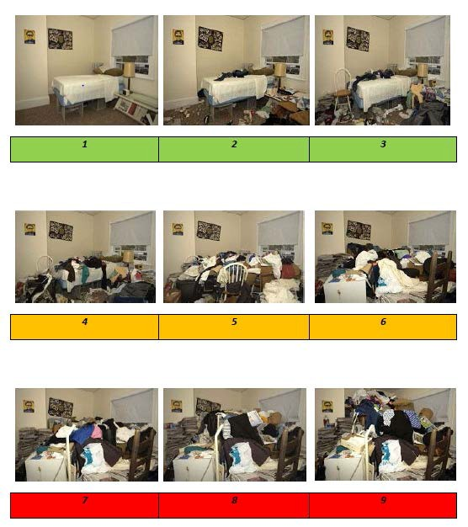
Clutter Image Ratings

Clutter Image Rating (CIR) – BEDROOM
Please select the CIR which closely relates to the amount of clutter
This guidance provides the following Clutter Image Ratings to identify the level of any possible hoarding, followed by guidance for practitioners, then courses of action for involved agencies to take dependent on the level of identified hoarding.
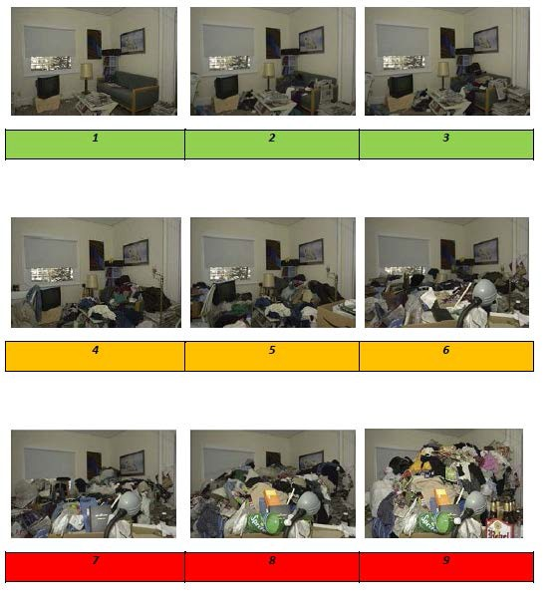

Clutter Image Rating (CIR) – LOUNGE
Please select the CIR which closely relates to the amount of clutter

Clutter Image Rating (CIR) – KITCHEN
Please select the CIR which closely relates to the amount of clutter

1 | 2 | 3
4 | 5 | 6
7 | 8 | 9

Level One Actions
Level 1 Clutter image rating 1 - 3
Household environment is considered standard. No specialised assistance is needed. If the resident would like some assistance with general housework or feels they are declining towards a higher clutter scale, appropriate referrals can be made subject to age and circumstances.
Level 1 | Actions – SEEK CONSENT BEFORE MAKING ANY REFERRALS
Referring Agency | - Discuss concerns with the Individual.  - Raise a request to local Fire & Rescue Service (&SFRS) for a Safe & Well Check and to provide fire safety advice.  - Refer to Adult Social Care for a Section 9 care needs assessment.  - Refer to GP if appropriate.
Environmental Health | - No action.
Social Landlords | - Provide details on debt advice if appropriate to circumstances.  - Refer to GP if appropriate.  - Refer to Adult Social Care for a Section 9 care needs assessment if appropriate.  - Provide details of support streams open to the resident via charities and self-help groups.  - Ensure residents are maintaining all tenancy conditions.  - Refer for tenancy support if appropriate.  - Ensure that all utilities are maintained and serviceable.
Practitioners | - Make appropriate referrals for support to other agencies.  - Refer to social landlord if the person is their tenant or leaseholder.
Emergency Services | - Local Fire Service - Carry out a Safe & Well Check if it fulfils Service criteria and share with statutory agencies with consent.  - South West Ambulance Service Foundation Trust (SWASFT) - Ensure information is shared with statutory agencies (request consent) & feedback is provided to referring agency on completion of home visits.
Animal Welfare | - No action unless advice requested.
Safeguarding of Adults and Children | - If there are adults or children presenting care and support needs living at the property they should be referred to the appropriate Social Care referral point by contacting Somerset Direct on 0300 123 2224.

Level Two Actions
Level 2 Clutter Image Rating 4 – 6
Household environment requires professional assistance to resolve the clutter and the maintenance issues in the property.
Level 2 | Actions – SEEK CONSENT BEFORE MAKING REFERRALS  In addition to actions listed below these cases need to be monitored regularly in the future due to RISK OF ESCALATION or REOCURRENCE
Referring Agency | - Refer to landlord if resident is a tenant.  - Refer to Environmental Health if resident is a freeholder.  - Raise a request to the local Fire Service to provide a Safe & Well Check with a consideration for monitored smoke alarms/ assistive technology.  - Provide details of garden services.  - Refer to Adult Social Care for a Section 9 care needs assessment.  - Referral to GP.  - Referral to debt advice if appropriate.  - Refer to animal welfare if there are animals at the property.  - Ensure information sharing with all necessary statutory agencies.
Environmental Health | - Carry out an inspection of the property utilising the referral form.  - At the time of inspection, Environmental Health Officer decides on appropriate course of action.  - Consider serving notices under Environmental Protection Act 1990, Prevention of Damage by Pests Act 1949 or Housing Act 2004.  - Consider Works in Default if notices not complied by occupier.
Social Landlord | - Visit resident to inspect the property & assess support needs.  - Refer internally to assist in the restoration of services to the property where appropriate.  - Ensure residents are maintaining all tenancy conditions.  - Enforce tenancy conditions relating to residents’ responsibilities.  - Ensure information sharing with all necessary statutory agencies.
Practitioners | - Ensure information sharing with all agencies involved to ensure a collaborative approach and a sustainable resolution.
Emergency Services | - Local Fire Service - Carry out a Safe & Well Check, share risk information with Statutory agencies and consider assistive technology.  - South Western Ambulance Service Foundation Trust - Ensure information is shared with statutory agencies (with consent) & feedback is provided to referring agency on completion of home visits via the referral form.
Animal Welfare | - Visit property to undertake a wellbeing check on animals at the property.  - Educate the person regarding animal welfare if appropriate.  - Provide advice / assistance with re-homing animals.
Safeguarding Adults and Children | - If there are adults or children presenting care and support needs at the living at the property they should be referred by contacting Somerset Direct on 0300 123 2224.

Level Three Actions
Level 3 Clutter image rating 7 - 9
Household environment will require intervention with a collaborative multi-agency approach with the involvement from a wide range of professionals. This level of hoarding constitutes a Safeguarding concern due to the significant risk to health of the householders, surrounding properties and residents. Residents are often unaware of the implication of their hoarding actions and oblivious to the risk it poses.

Level 3 | Actions
Referring Agency | - Raise Safeguarding concern with Somerset Direct within 24 hours by telephoning Somerset Direct on 0300 123 2224 – or sooner if you feel there are risks that could materialize imminently  - Raise a request to local Fire Service within 24 hours (or sooner if appropriate) to flag up the level of risk, and to consider a Safe & Well Check.  - Refer to Environmental Health via the referral form.
Environmental Health | - Carry out an inspection.  - At time of inspection, Environmental Health Officer decides on appropriate course of action.  - Consider serving notices under Environmental Protection Act 1990, Prevention of Damage by Pests Act 1949 or Housing Act 2004.  - Consider Works in Default if notices not complied by occupier.
Landlord | - Visit resident to inspect the property & assess support needs.  - Attend multi agency hoarding meeting.  - Enforce tenancy conditions relating to residents’ responsibilities.
Practitioners | - Refer to “Hoarding Guidance Questions for practitioners”.  - Complete Practitioners Assessment Tool.  - Ensure information sharing with all agencies involved to ensure collaborative approach and sustainable resolution.
Emergency Services | - Local Fire Service- Carry out a Safe & Well Check, share risk information with statutory agencies and consider assistive technology.  - South West Ambulance Service Foundation Trust (SWASFT) - Ensure information is shared with statutory agencies & feedback is provided to referring agency on completion of home visits via the referral form.  - Attend hoarding multi agency meetings on request.  - Ensure information sharing with all agencies involved to ensure a collaborative approach and a sustainable resolution.  - Provide feedback to referring agency on completion of home visits.
Animal Welfare | - Visit property to undertake a wellbeing check on animals at the property.  - Remove animals to a safe environment.  - Educate the person regarding animal welfare if appropriate.  - Take legal action for animal cruelty if appropriate.  - Provide advice / assistance with re-homing animals.

General Points to Consider
- Always seek the consent of the individual before making a referral or sharing information – refer to the Somerset Safeguarding Adults Board and own organisational information sharing protocols.
- If consent is not given but you feel there is a significant risk of harm to either the individual themselves or others (for instance children living in hoarded properties, where there are fire risks for both the individual or to neighbours in terraced properties, or where there is a risk of harm to fire-fighters should they need to enter a property with significant hoarding or structural defects etc.), consult your line manager at that time for further advice.
- Additionally, seek advice from the Devon and Somerset Fire and Rescue Service – remember, you can discuss your concerns in general terms to establish whether the risks justify you sharing information without consent.
- If you have any safeguarding concerns you must make a referral that time. Further guidance on the referral process on can be found here.

