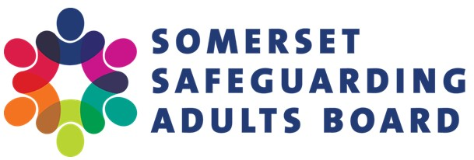

**Annual Conference 2023**

**02/03/2023**

The conference, primarily aimed at safeguarding leads working for organisations that operate within Somerset, is intended to provide an opportunity to learn about current and emerging areas of safeguarding work to inform organisational safeguarding practice.

* Venue: **Canalside,** **Marsh Lane, Bridgwater,** **Somerset TA6 6LQ**

**Agenda**

|  |  |
| --- | --- |
| 09:30–10:00 | Arrival and refreshments |
| 10:00–10:15 | Welcome by SSAB Independent Chair – Michael Preston-Shoot |
| 10:15–11:00 | Self-Neglect, Individual: Michael Preston-Shoot |
| 11:00–11:45 | Breakout session 1. When booking please select from:   * Whose Rights Are We Safeguarding? - *The Mental Capacity Act and Safeguarding Adults* - Emma Lawton * Making Safeguarding Family Centric - Jess Heslop, Dimensions |
| 11:45–12:00 | Break with refreshments available |
| 12:00–12:45 | How Personal is our Safeguarding? – Dr Adi Cooper (Virtual) |
| 12:45–13:30 | Buffet lunch |
| 13:30–14:15 | How do I Assess and Manage Risk? – Tabletop Exercise - Kate Greenwood |
| 14:20–15:20 | Breakout session 2. When booking please select from:   * Advocacy, Not One Size Fits All: SWAN * Helping to Help Ourselves - *How providers can prevent safeguarding situations from a QA perspective*: Chloe Cox/Rachel Caunce * Power to the People - *Demystifying Section 42 Enquiries within regulatory care settings, including hints, tips and learning themes* – Amy Rogers/Jess Rogers * Not in my Establishment! Closed Cultures: *Understanding the challenges and how we can address this to support the individual* – Jason Bardell, Dimensions |
| 15:20–15:35 | Break with refreshments available |
| 15:40–16:20 | It’s Personal to Me – The Misfits Theatre Company |
| 16:20–16:30 | Conference close by SSAB Independent Chair |

If you require further information, please contact [ssab@somerset.gov.uk](mailto:ssab@somerset.gov.uk)